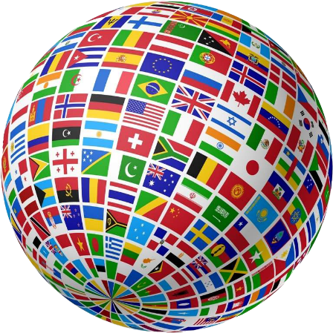
Resources for Country Information

www.rphslibrary.org/databases

^{Password: panthers}

CIA World Factbook

https://www.cia.gov/library/publications/resources/the-world-factbook/index.html

Encyclopedia Britannica

www.britannica.com

mapmaker.nationalgeographic.org

Currency converter

www.xe.com/currencyconverter

